**ISSUE1**:To Install Salesforce Extension pack I am getting the below error message

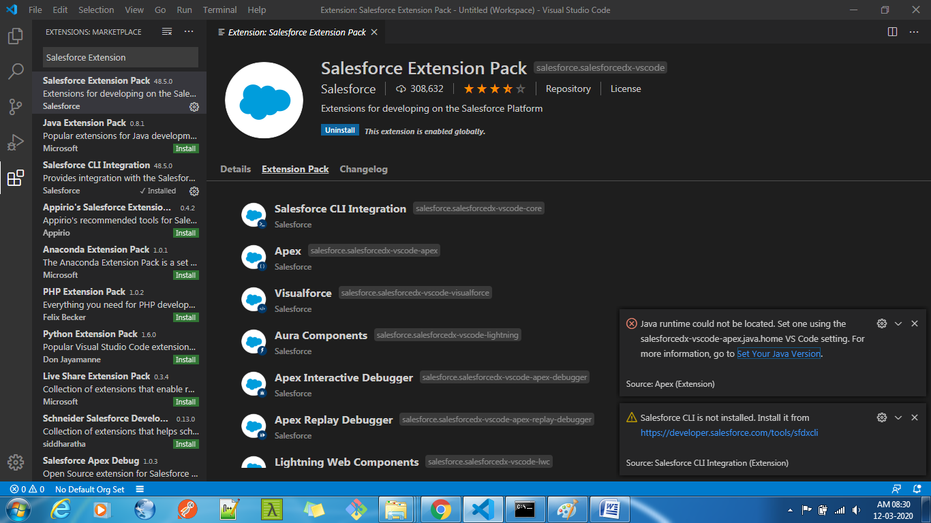

To solve JAVA problem Follow the below steps

1.Install JDK(In my case it is JDK 8(SE))

2.Go to “Environment variables”

a) Select the path of JDK and JRE “Bin” folder and paste it in the “System Variable” path

C:\Program Files\Java\jdk1.8.0_241\bin

C:\Program Files\Java\jre1.8.0_241\bin

b) Now go to “User Variables” and create a new variable “JAVA_HOME”

copy the JDK path and paste it (C:\Program Files\Java\jdk1.8.0_241). save it

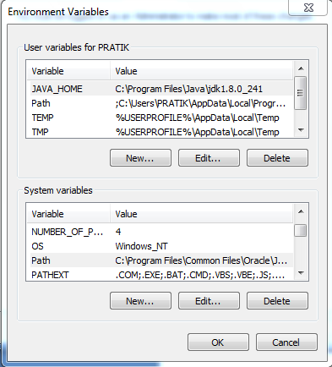

To Solve the CLI problem

Install CLI(<https://developer.salesforce.com/tools/sfdxcli>)

Open Command prompt 🡪Sfdx update(To update the CLI)

Once JDK and CLI installed properly, Install Salesforce Extension pack